Dear Friends,


It is so amazing to be sitting here writing another pastoral letter for Christmas. It seems only a moment ago since I wrote the previous one. Many things have happened in our lives but not the one thing we long for, which is to see the Spirit of God moving powerfully in our nation and in our parish area. The financial situation in the world is teetering on the edge of disaster, problems in family life seem to be as tragic as ever with no improvement, the moral values of our nation increasingly is hostile to Christian, biblical values and the more we try out our schemes to bring about change for the better the more we get ourselves into quicksand.

Would it not be so wonderful to experience the glory of the advent of Jesus Christ written about in Isaiah the prophet in these words, ‘The people walking in darkness have seen a great light, on those living in the land of the shadow of death a light has dawned…’ (Isaiah chapter 9 verse 2)

In the dark it is so easy to bump onto things you cannot see and injure yourself, cause problems that are unforeseen and that we do not know the cause of and therefore the answer to it. This is true in the moral and spiritual realms of human life as much as it is in the physical realm.

Jesus is the ‘Light of the world’ and when he was born, when ‘The Word was made flesh’, the light came into the world. However, it is instructive to note the context in which Matthew quotes this text from Isaiah. Jesus had been baptised by John, the voice of approval from his Father was heard and the Spirit had impelled him into the desert to be tempted by the Devil. Then, when Jesus came from the period of testing (or probation) and temptation, Matthew quotes these words.

He was telling us that the light which had come into the world had not yielded in any way to a fallen humanity or the tests that God had given him or the temptations that the evil one had put him through had every right to shine into our spiritual and moral darkness. It was because Jesus relationship with his Father was perfect and because of his moral perfection before him that a whole new era opened up in our world’s history. At last the one God promised who would crush the serpent’s head had come.

To come from darkness into light personally is to come to Jesus Christ in order to believe in him and trust in him for salvation. He will cause ‘the light of the glory of God in the face of Christ Jesus to shine into your hearts’ by the Holy Spirit this Christmas if you but seek his grace and mercy.

May the Lord Jesus Christ himself shine into your heart and bless you in ways that you could never have imagined possible, for as we read in the birth narrative in Luke, ‘With God nothing is impossible.’

With much love and sincere greetings,

Richard G Buckley

Congratulations to Ruth Calley

Members of the Congregation will remember Tom and Elaine Calley, who moved with Ruth, Naomi and Thomas to Dalry, North Ayrshire, in June, 2006.

Ruth attends Dalry Primary School, and two paintings she did at school were selected to represent ‘North Ayrshire’ at an exhibition in The Harbour Arts Centre, Irvine.



In addition one of Ruth’s paintings (on her right) has been chosen by the Head of Social Work for North Ayrshire to hang on the wall in her new office.

Congratulations to Ruth from all at TPHD on a fantastic achievement.
LONG SERVICE PRESENTATION

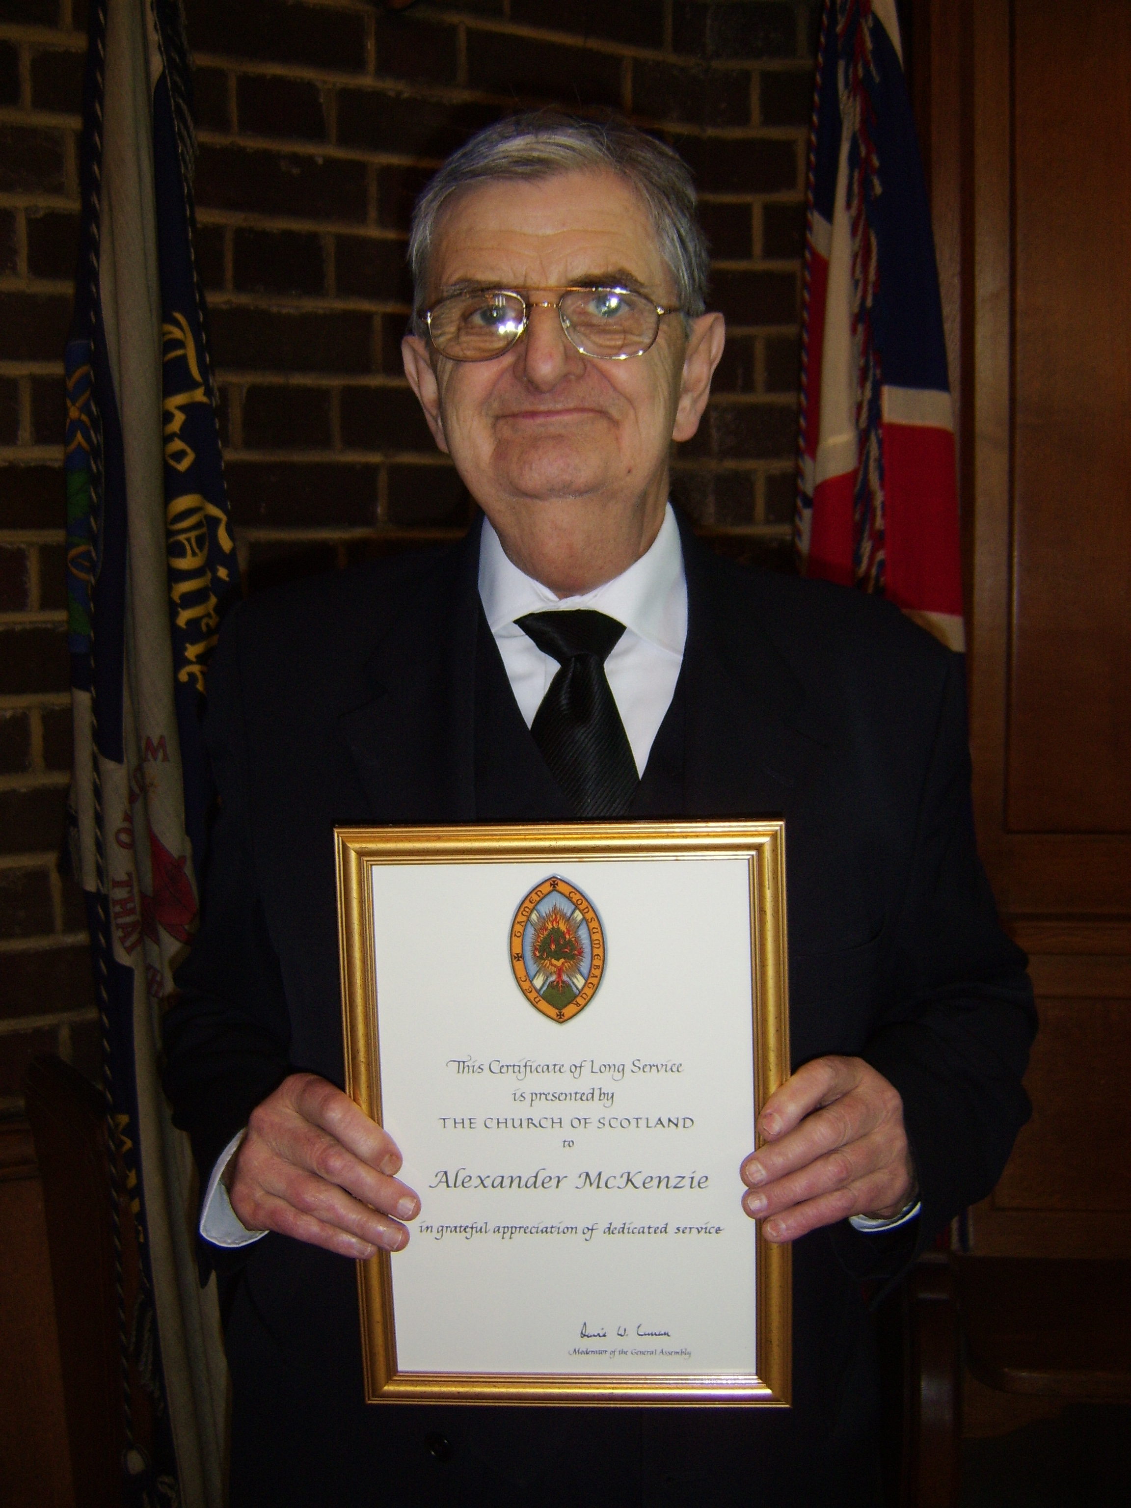
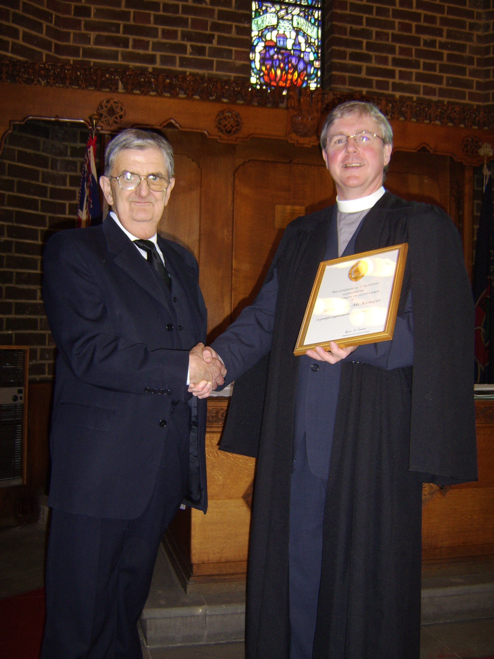
Mr McKenzie is shown being presented with his Long Service Certificate at the October Morning Communion Service.

Here Mr McKenzie reflects on some early influences on his life:

I was baptised in January 1936 and was first taken by my mother to Johnstone Church, Springburn, when I was 3½ years old.

I told my father I wanted to join the 25th Glasgow Lifeboys at Cowlairs Parish Church. He agreed on condition that I went for three weeks, and once I received my uniform I would have to continue. I did - and received my discharge from the Company Section at 18 years old on 3rd June 1953 when along with another 6 boys I joined the church. I became an Officer and Sunday School teacher.
The first memory of Cowlairs was being shown the Bible being taken up to the pulpit and opened also the open Bible on the lectern, a symbol of the authority of the Bible in the Church.

In 1978 I was ordained into Eldership. I consider myself as a traditional Church of Scotland Bible based Evangelical. My faith can be summed up in the song, “Jesus loves me, this I know”.

The Boys Brigade, which has meant so much to me, was founded in 1883 on the text Hebrews 6:19 – ‘This hope we have as an anchor of the soul, both sure and steadfast’. The BB hymn asks the question, “Will your anchor hold in the storms of life?”
I can truly say my anchor is grounded firm and deep in my Saviour’s love.

A. McKenzie


Emmaus

Emmaus started in post World War 2 France by Abbé Pierre. Abbé Pierre was a French priest, who was a member of the French Resistance during the war (Abbé Pierre was his code name), and after the war he saw people, with nowhere to go, raking through bins to find items to sell. He was also a Member of the French Parliament so he had an income, so he bought a big house and took some of these people in to stay with him. They started taking in things to refurbish and sell, thus started the Emmaus recycling programme, which is now a large part of the organisation.

Emmaus, which is non-denomination organization, spread throughout France, and the whole of Europe and Abbé Pierre became a very revered man in France until his death at 93 in January, 2007.

Emmaus came to Britain in the early 1990s and the first Community opened in Cambridge. The President of Emmaus in the UK is Terry Waite. There are now approximately 15 Communities in England.

Emmaus Glasgow opened in January, 2007, and is the first Community in Scotland. We provide a home, and work, for people who have been homeless. All of our residents, known as ‘Companions’, give up primary benefits from the state. They have to work (to the best of their ability), and in return they are provided with accommodation, toiletries, and food, plus an allowance of £37.00 per week (£5.00 of which goes into savings). The Community collects Housing Benefit on behalf of the Companions.

Companions work on a variety of tasks, mostly in recycling used household goods such as furniture, televisions, white goods and bric-a-brac. In our workshop damaged and worn furniture is repaired and restored. Electrical equipment is tested to ensure it is safe for use.

Emmaus has a shop at 101 Ellesmere Street (the old Grove Mission) and which is going from strength to strength with tremendous support from the local Community. In July of this year we opened a shop at Bridgeton Cross. The official opening will be on 15th November by Terry Waite and Lorraine Kelly.
The shops are open Monday to Thursday 9.00 a.m. to 4.00 p.m., and Friday 9.00 a.m. to 3.30 p.m., and you would be most welcome to come along to browse and see what we have.

If you would like to donate furniture or bric-a-brac please telephone 0141 353 3903.

Please note that furniture must have fire labels.

The name Emmaus was taken from Luke Chapter 24 where the two disciples, despondent after the crucifixion, were walking on the road to Emmaus when they met a stranger. They walked with him and, on reaching Emmaus, invited him to eat with them. He revealed himself as their risen Lord, and Emmaus became a place of hope for them. We hope that similarly Emmaus will be a place of hope for the homeless people who come to live in the Community. We do not know who we will meet on the road of life and everyone is welcome at our table.

Norma McKenzie

LIVE LONGER – GO TO CHURCH

Going to church every week can help you live longer, say scientists.In fact, if you attend two services a week you can cut your chances of dying by 20%.
The remarkable findings come from a vast, long-term US government-funded study of the health of 92,000 women.
The difference in death rates cannot be explained away by factors like social support provided by the church, or the possibility that religious people lead healthier lifestyles, said study leader Dr Eliezer Schnall.
“There is something going on here that we don’t quite understand,” he added from his base at the Albert Einstein College of Medicine in New York.
The findings, published in the journal Psychology and Health, were based on interviews with Christians aged 50 to 80.
They came from all denominations and were questioned over eight years.

From Wilma Johnston


May I take this opportunity to express sincere thanks for the many cards, letters, phone calls, flowers from members of the congregation, and most importantly, spiritual uplifting from Mr Buckley during my recent operation from which I’m recovering slowly.

This was indeed Christian love in action

Ella Crichton



Joyce, Kenneth, and Elaine Irvine would like to thank everyone in the Congregation for their support over the summer following the death of their mum, Margaret. The church holds many fond memories for us from when we attended regularly as a family with our father John, who was a prominent elder in the church for many years. We all learned a lot from our participation in the Girls' and Boys' Brigades, and our attendance at Sunday worship. The photographs in the church hall reminded us of the many happy times we had spent there. Even at this sad time, it was good to renew many old acquaintances.

We are particularly grateful to the Rev Richard Buckley for the kindness he showed to us, and for the compassionate way he conducted our mum's funeral service.

TPHD AND THE WORLD WIDE WEB


Our logo states ‘TPHD Building in the 21st Century’. Well, we can report that not only are we building in the 21st century but we have reached out into the 21st century and booked our place on the World Wide Web where friends can view our website!

http://trinitypossilandhenrydrummondchurch.synthasite.com/

The above link will take visitors to our website where they can read of our church, our aims and our history. It is early days and we are continuing to add information and photographs to the website.

The website has had ‘hits’ from Glasgow, London, Newbury, Aberdeen, Manchester, Newbury, Hayes, Liverpool and Inverness in the UK, and from overseas Adelaide (Australia), Mokena (USA), Flumicino (Italy) and Vancouver (Canada).

Any readers who have photos or information which they feel would be of interest to our site visitors please contact Isabel Whyte.



TPHD 2009 DIARIES



Diaries are currently on sale priced £3.00 !

With 2009 almost here, buy yours to-day and avoid disappointment!
See Isabel Whyte, Jean Ross or Norma McKenzie.
SOMETHING TO THINK ABOUT

Dear fellow-members of TPHD,

I take this opportunity to wish all of you a very blessed Christmas and a wonderful New Year.

It does not seem like a year since I last wrote, but I felt I must write again, and perhaps some will read what I have to say - the future of individual lives is very much at stake.

God wants us to come to Him and plead for mercy. Satan seems to have a very strong grip on many otherwise wonderful people, but whom God rightly calls, sinners – those who live their lives as if there were no God, and who deny the love of God. But they are so terribly wrong.

God is a kind, patient, loving God, and full of mercy. He does not want us to stray from Him: He has many wonderful things to give us if we will repent and come to Him. In sermon after sermon we hear of the Lord crying to us to cast our burdens upon Him and repent of our sin. Thus far, it is not too late, but who knows?

As you know, there are 3 services of worship most weeks – morning and evening on Sundays, and a Prayer meeting on Wednesdays. Sadly, not a lot of people come to hear the Lord speaking through His servant. The Prayer Meeting spends a lot of time pleading with God to save our people.

The pressing question is, “Why will you die – eternally, separated from God?” The fact remains that if you do not have Jesus as your Saviour, you will be eternally cut off from God and Jesus forever. How strange it is that many will choose death eternally rather than life eternal with the One who made you and loves you.

This is God’s answer to the problem. How will you respond? Will you give these vital issues your earnest consideration? May God bless you in these momentous days of decision and lead you into the fullness of life.

With much love and concern,

Willie Young


On Sunday 7th November 2008 Mrs Isabel McLeod celebrated her 90th Birthday!

Members of the congregation gathered in the Large Hall where we sang ‘Happy Birthday’ to Mrs McLeod and all enjoyed sharing in her celebration and her birthday cake!

We look forward to celebrating many more birthdays with Mrs McLeod.

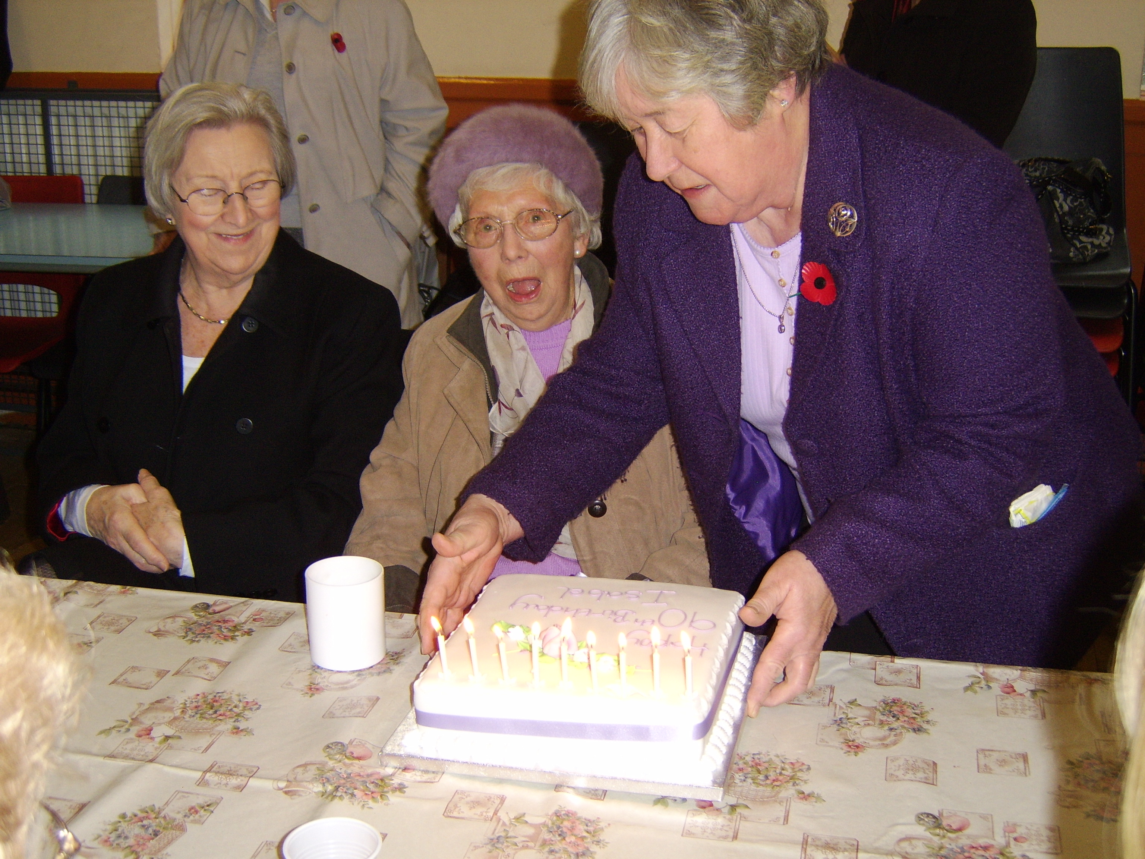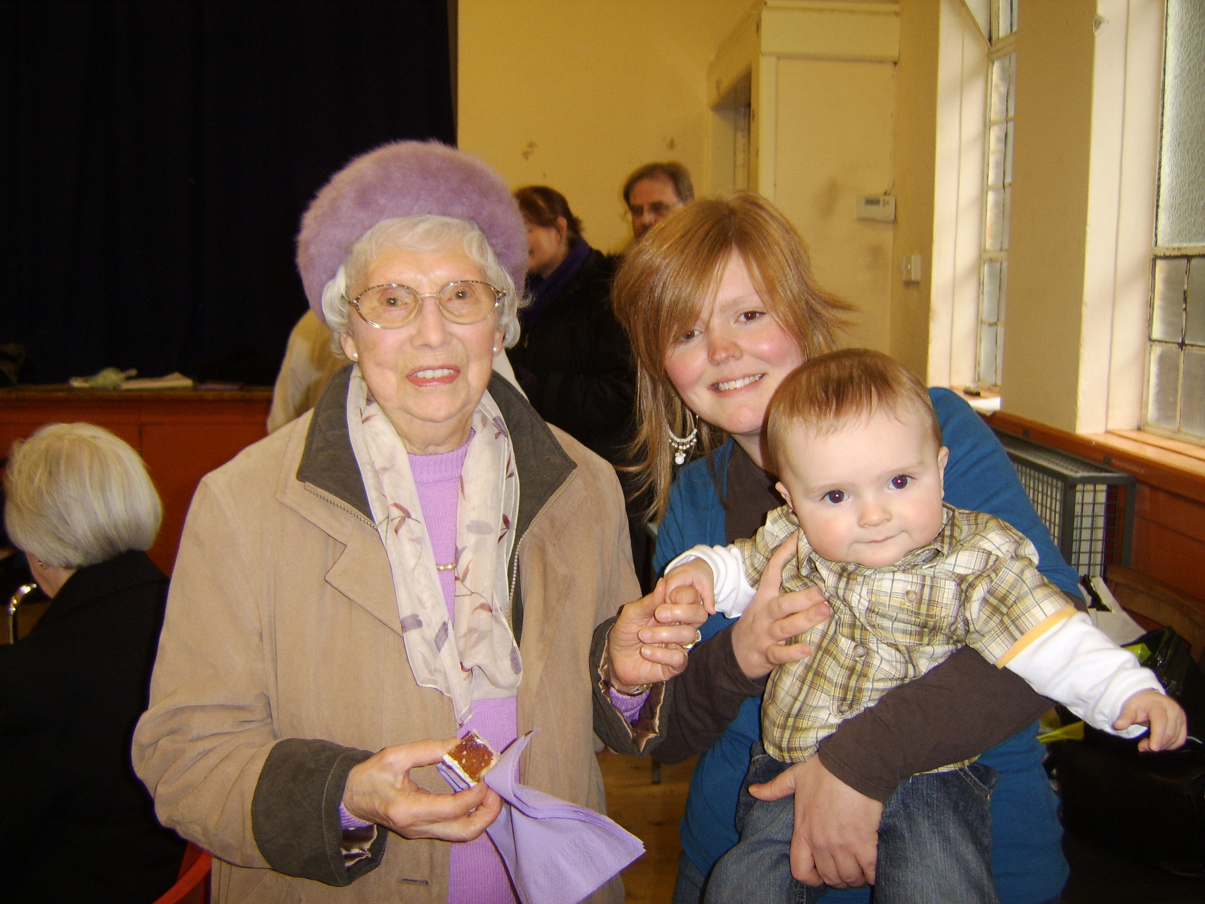

A surprised Mrs McLeod at her ‘birthday bash’ ; Samuel Buckley (& Debbie) joined in the birthday celebrations too!

Mrs McLeod writes:

“I would like to thank the Minister and congregation for their cards, gifts and good wishes as I celebrated my 90th birthday. These expressions of kindness were greatly appreciated. ”

I thank my God every time I remember you. Philippians 1:3
CHRISTIANITY EXPLORED : REVISED FORMAT



Before we started our latest Christianity Explored Course we took stock of what people were saying and made some changes. The main one was to make the meetings fortnightly instead of weekly. We did this for two reasons: to avoid European football matches which take place on alternate Tuesdays, but more importantly, because we felt that a weekly meeting resembled a night school class and people were not being given time to digest what was being said.

The course this year has been the most successful ever, in terms of attendance, with up to 24 people coming along on Tuesday nights – this is was also good news for the Chip Chik Inn on Hawthorn Street who had to provide fish suppers for 18 at the end of the first block of teaching!

We have also seen a few more people from the church coming along to support. This is good as it opens up the prospect of running more courses, perhaps even simultaneously.

The main point of Christianity Explored is to try to introduce people who have never heard the gospel to the person and claims of Jesus Christ. Finding new people is the challenge, and visiting the people in the parish - while hard work - has resulted in one or two people coming along.

It’s interesting to note that all those who have come through Christianity Explored and now come to church regularly have had a church background. Maybe you know someone, or have a neighbour, who used to go to church and no longer attends. Maybe they would find going along to the next Christianity Explored Course less threatening than going back to church.

Invitations to the next course which will start next March will be available in January. Every church member should be involved – Christ’s last word to his disciples (that’s you and me) is that they go into all the world (even Lambhill and Parkhouse) and make disciples.

Robert Wilson
2008 COVENANTER TOUR

As another Scottish winter starts to blow around us we should spare a thought for those who used to attend conventicles – meetings held in remote parts of Scotland where the Covenanters assembled generally for several hours to sing psalms and listen to the word of God preached.
The meetings were unlawful and those who met risked arrest, deportation and even death.

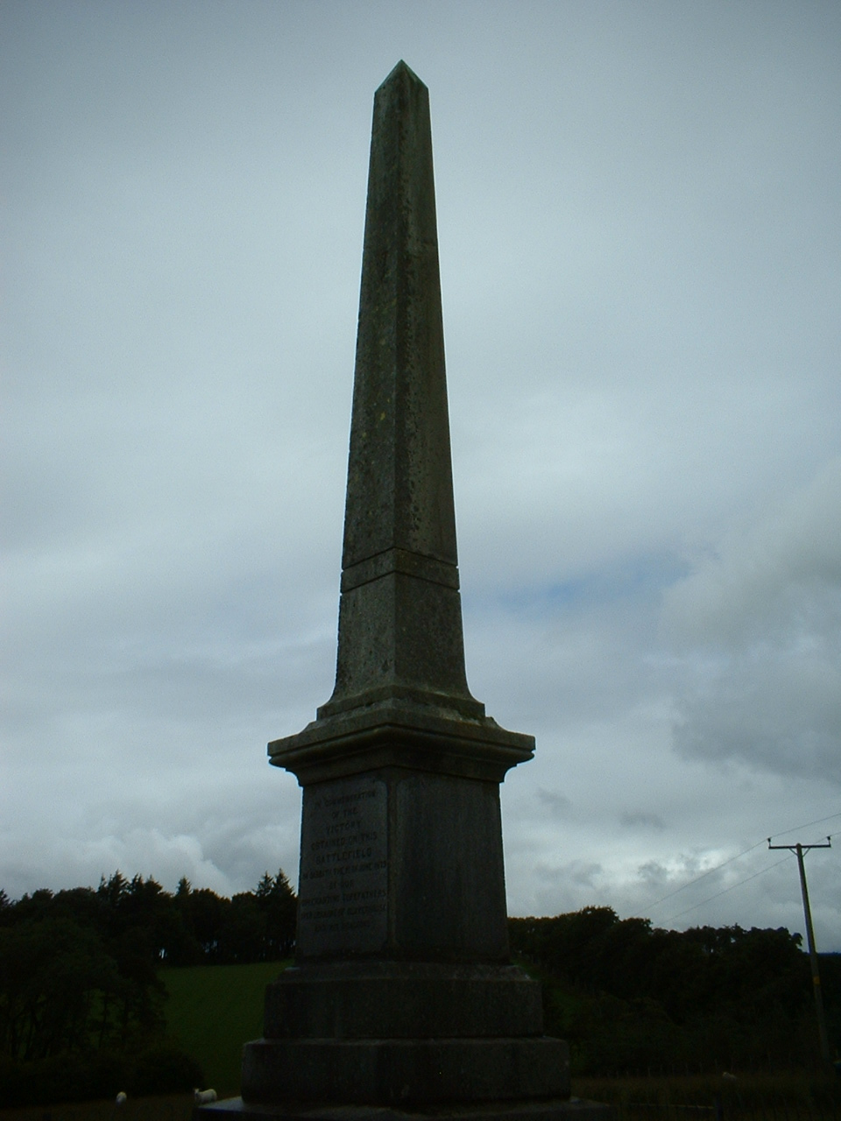

24 Church members got a small taste of what a Conventicle was like in July this year when our Covenanter Tour bus run stopped at the memorial to the battle of Drumclog (just outside Strathaven).

We stopped for 10 minutes and sang the Drumclog Psalm – Psalm 76
"In Judah's land God is well known,
His name's in Israel great;
In Salem is His tabernacle,
In Zion is His seat”

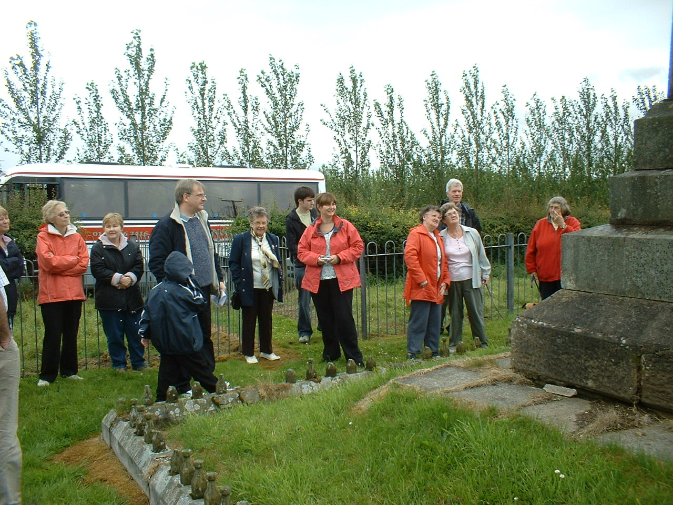
The effect was memorable – sheep who had been taking a passing interest in our presence ran away as quickly as they could.
We were feeling a bit cold then so we got in the bus and continued our tour which included the Trumpeter’s Well, Newmilns churchyard, Fenwick Churchyard, Ayr churchyard and The Bothwell Bridge Memorial.

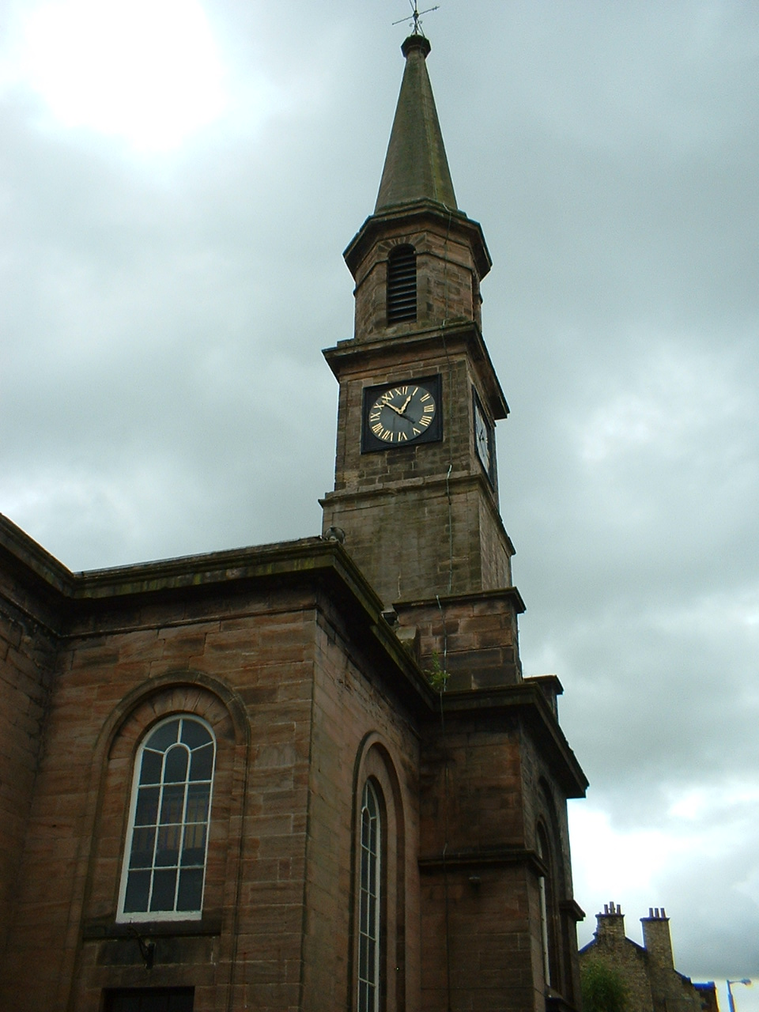

Newmilns Church

The churchyard
contains the resting place
of several
Covenanters

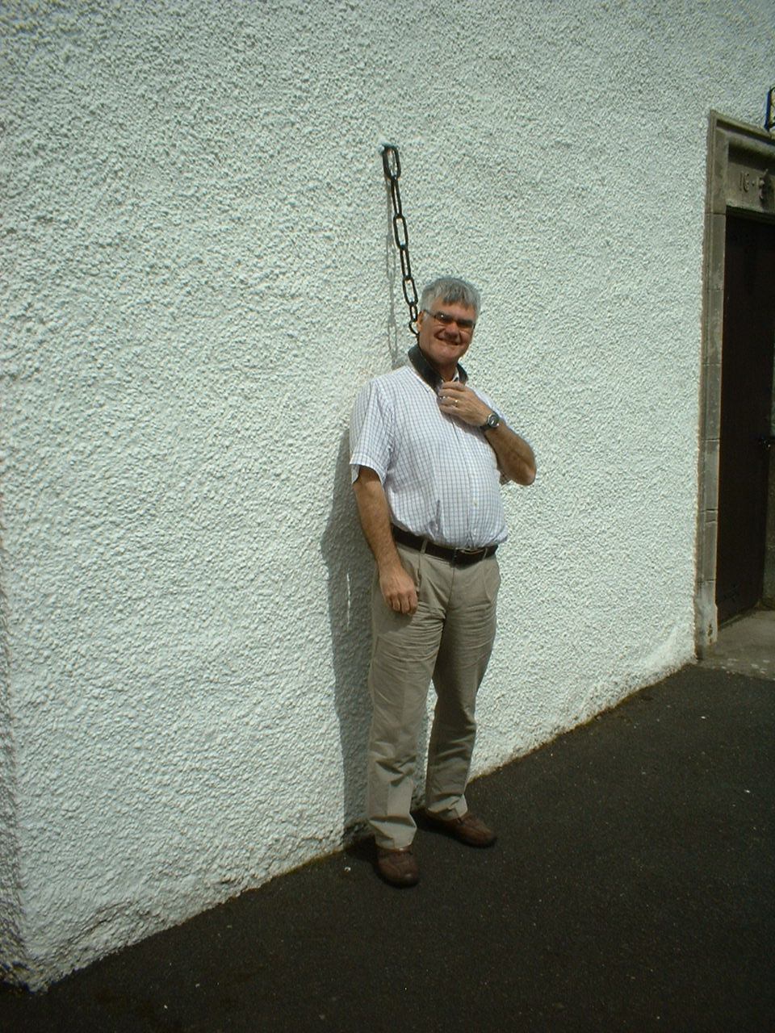

Fenwick Church

Mr Robert Wilson,
Clerk to the Congregational Board,
in the jougs !

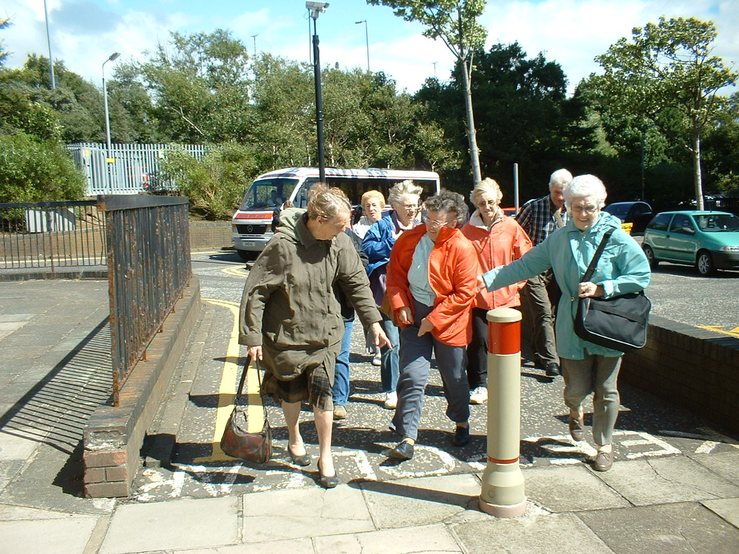

A windy spot
in Ayr!

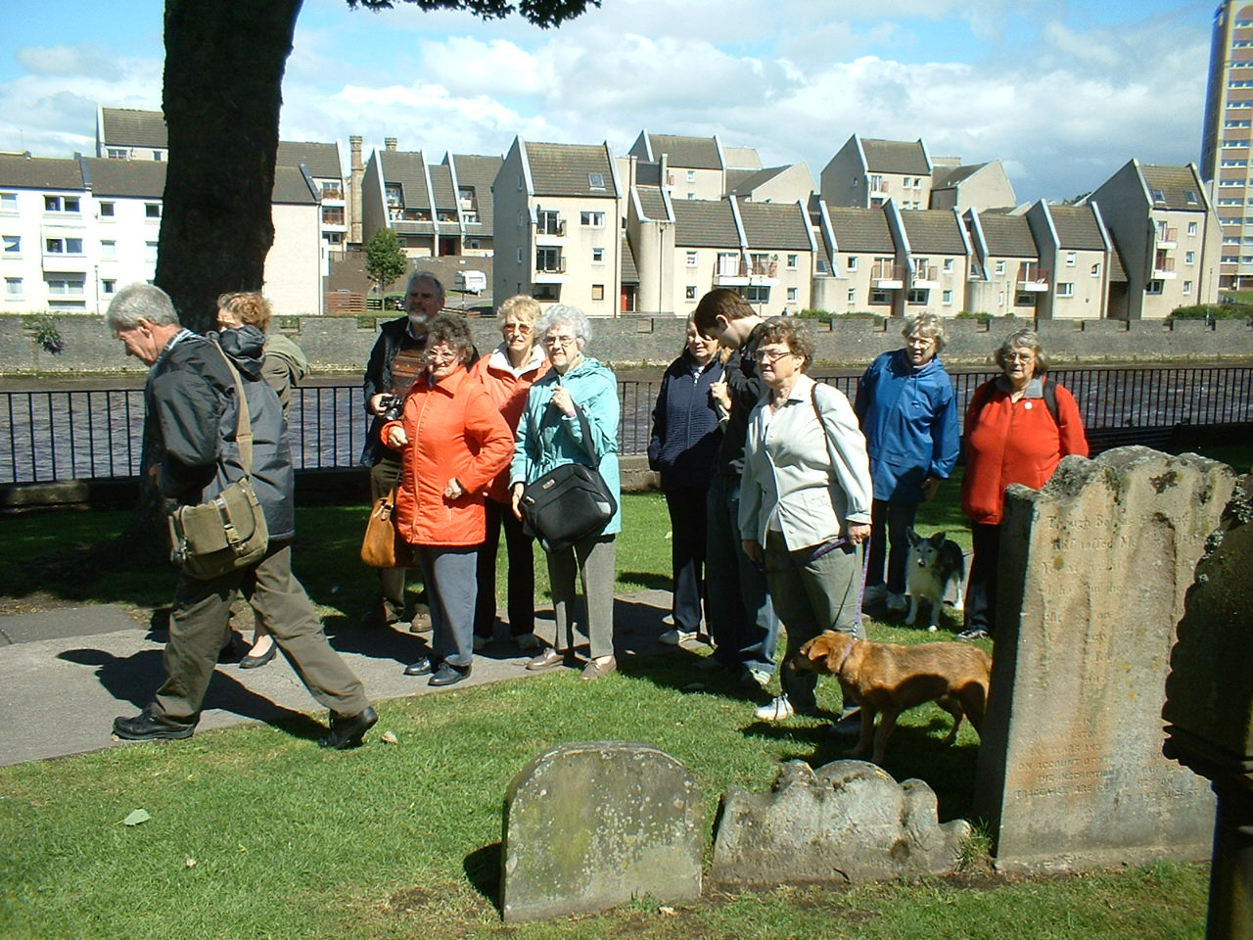
At Covenanters’ graves in Ayr
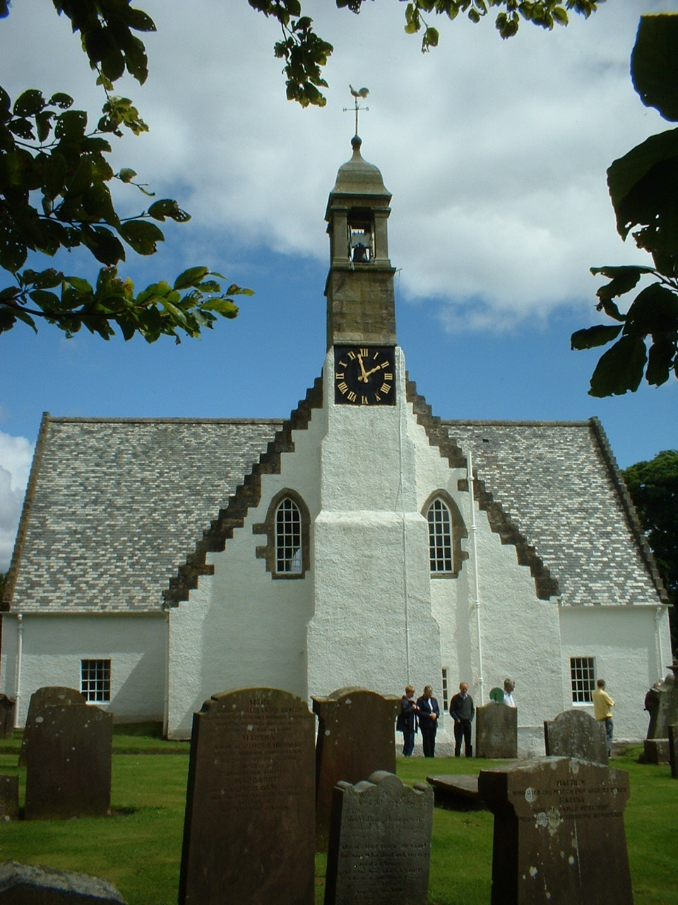

Fenwick Church

Here are interred many Covenanters who were prepared to give their lives for the sake of Christ and the cause of the Gospel in this country. In order for the visitor to be able to find the location of their graves, their graves or tombstones are marked with a distinctive ‘Fenwick Covenanter’ plaque.

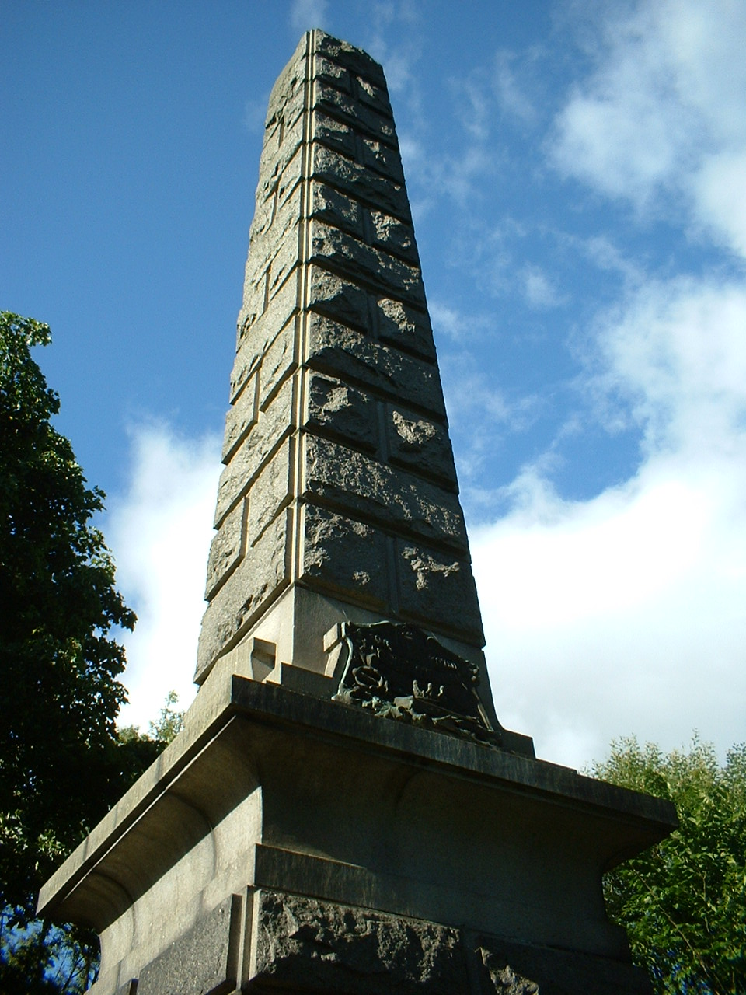

The Bothwell Bridge Memorial

In the end we had a sunny day and everyone ended up fairly exhausted but knowing a lot more about he men and women who had given their lives for the Gospel over 350 years ago.

There will be another – but different - Covenanter tour in 2009!

Robert Wilson
Each year the Congregational Board tries to find a needy cause for our Gift Service. We were grateful to Morag Ann Girvan for bringing the desperate plight of this young girl to our attention.


OUR CHRISTMAS PROJECT
- A WHEELCHAIR FOR CHIPO

Chipo - her name means 'gift' – Nyamuzinga
is 7 years old and suffers from cerebral palsy.
She is the 6th of 7 children.

Because of her problems with muscle tone Chipo's head flops and she suffers from spasms and has no coordination. As a consequence she needs the physical support of others and has to be carried from place to place. She is now getting too big to carry.

Her mother receives little or no help. She has few resources and given the situation in Zimbabwe the family has no work. Chipo's mother is depressed and has lost a lot of weight. The little land that they have is used to grow vegetables for food and to provide money for themselves they have taken a lodger.

In Zimbabwe a condition like cerebral palsy is seen as a punishment and the mother is often blamed for the illness - in their culture the husbands or males refuse to help or provide any assistance.

Chipo has never been to school but her mother would love her to be educated - a wheelchair would mean that Chipo would not have to be carried everywhere - she could move around the house and would be able to be transported to school.

I am at College with Chipo's sister Susan. Susan is so concerned for her sister and her family and sends home what little money she has to help alleviate their difficulties.
Susan herself does not keep well - her legs were crushed when she was young and there are days where she just cannot manage to college.

If you would like to help, please put your donation in the envelope provided and bring it to the Christmas Gift Service.



11 am SUNDAY 14TH DECEMBER
CHRISTMAS GIFT SERVICE


SUNDAY 21 st DECEMBER
11 am FAMILY SERVICE
6.30pm CAROL SERVICE


11.30pm CHRISTMAS EVE
WATCHNIGHT SERVICE
with
refreshments available in the Large Hall
from 10.45pm

CHURCH (ALL-AGE) PARTY
for EVERYBODY IN THE CONGREGATION!
will be on
FRIDAY 12TH DECEMBER 2008
7.30pm – 9.30pm

